Russian weekly grain, end of week report, July 11-12, 2025
IKAR
Not for reproduction and redistribution. It is our policy that RWG and its parts are NOT distributed and NOT meant to ANY government body or agency. Thank you for your understanding and cooperation

Graph of the week: our harvest yields graph analyzer (preliminary regional data)

Krasnodar cumulative barley yields have made an unusual and impressive elevation from inceptional 4.9 to 5.8 t/ha (although it’s preliminary regional data). We forecasted that wheat would repeat the same type of trajectory, however, now we think differently. Yes, wheat yields gradually increase across the entire Golden Triangle of Krasnodar/Rostov/Stavropol, but, it looks obvious, they will finish lower than at forecasted rate and level. One of the factors/reasons for lower than forecasted yields is associated with extremely hot and dry weather in the South, that causes water evaporation from the kernels, and affects both TW and the yields.

Hot topics and headlines

Later on Monday IKAR will officially lower its domestic wheat production forecast from previous 84.5 to 84.0 mmt… with prospects of further lowering this figure (but it’s just an unofficial early warning for our subscribers,pls keep it confidential)… We see lower than expected yields in three out of four key regions of Gross South: Rostov, Krasnodar, and Stavropol, while Volgograd currently looks in line with our yields expectations. Both South, Central, and Volga have been affected by extremely hot and dry weather, that is accompanied by quick water evaporation from the kernels (from, say, 14 to 9-10%), lowering test weight and relevant yields...

According to the current forecast, the daily temps will go down to 30+C, but dry weather across the South half of European Russia will continue for at least another week. It may lead to (further) deterioration of spring crops. Both corn, soybeans, and suns are in the stage of flowering; spring wheat and barley are in the stage of filling.
***
Wheat quality-wise, we continue to distinguish two Gross South quality strata: 13.5-16% European protein/low TW (70 and below), and 10-11.5% protein/normal TW (78 and higher).

Most recent anxious quality news from Volgograd, Saratov, Orenburg: some first harvested fields show (very) low – to different - FN. The combination of recent showers with very hot weather provoked “awakening” of kernels. It is not sprouting yet, but FN is affected… Taking in mind that during next - decisive – week the vast region will experience combination of rains with hot temps, we are afraid, the problem may aggravate… As usual, at the moment we receive highly contradictory leaks, such is some fields fix FN down to 60 (N.Volgograd – S.Saratov)… One of trustworthy massive land banks in the left bank of Volga: 1/3 of collected wheat is below 160 FN, another 1/3 is below 250, final 1/3 – is normal milling wheat of 250-350…

Most recent news from South and Central Samara: good yields, but the same issues with FN, harvested fields show 65-200 range, with main range between 70-140… Locals report they don’tremember so low figures…
***
We continue to keep our July wheat export shipments level at very modest 2 mmt, but may be, last moment, higher. Line-ups are back to normal (high) levels…
***
FOB Black Sea 12.5% wheat price index is now seen at $229 per ton, 11.5% is not seen as massive Russian item yet, but if to take Ukrainian as a reference it would be $223. FOB barley price index is seen at $205 per ton…

Both wheat and barley weekly export duties remain at zero level…

Meanwhile, during the week short covering in the ports was deepening. Our CPT export terminals Black Sea 12.5% price index is further up and already seen at RUR15800-15900. Azov Sea CPT price is seen now at RUR14800-14900...
***
Amid new crop arrival and growing logistical workload, our two-week South Russian grain truck freight transportation index is predictably up…

Hot topiс 1. Export activities. We continue to keep our July wheat export shipments level at very modest 2 mmt, but may be, last moment, higher. In addition to late crop arrival, heavy workload of farmers with current crop collection and placement activities, and their hesitation regarding prices, there is a relatively new factor: issuing necessary official docs for shipping cargo from the farm…

July 1-11 five Black Sea terminals and Novo container terminal export shipments are miserable of 104 tmt: 31 tmt of barley, the rest is wheat. Visible line-ups are further sharply up to 1180 tmt of wheat and barley in comparison with 784 tmt, a week ago…

July 1-11 Port Kavkaz shipments shipped first 26 tmt of wheat, to Tukiye. Visible line-ups are strogly up to 560 tmt of wheat in comparison with 311 tmt a week and 164 tmt two weeks ago... Egypt, S.Aabia, Bangladesh are among the export destination leaders.

July 1-11 Azov Sea shipments are 186 tmt, predominantly wheat, but 61 tmt of corn to Turkiye too.

Caspian Sea is fully back to life: we see about 100 tmt of predominantly corn, and a little barley shipped to Iran. Barley eventually to be come bigger market.

July Port Vysotsk shipments are 37 combo wheat to Morocco, to be followed by 50 tmt of pea to India, and 5 tmt of flax to Belgium. Then 25-30 tmt of wheat combo to Cuba to be shipped at the end of July-beginning of August…

Weekly all ports wheat shipments, as of July 11, tmt

Cumulative all ports wheat shipments, as of July 11, tmt

Weekly grains shipments from 5 Black Sea terminals as of July 11, tmt

Cumulative grains shipments from 5 Black Sea terminals, as of July 11, tmt

Weekly grains shipments from Azov Sea to Port Kavkaz anchor transshipment station, as of July 11, tmt

Cumulative grains shipments from Azov Sea to Port Kavkaz anchor transshipment station, as of July 11, tmt

Weekly wheat shipments to Turkiye, as of July 11, tmt*

Cumulative wheat shipments to Turkiye, as of July 11, tmt

Five Black Sea terminals and Port Kavkaz visible line-ups, tmt
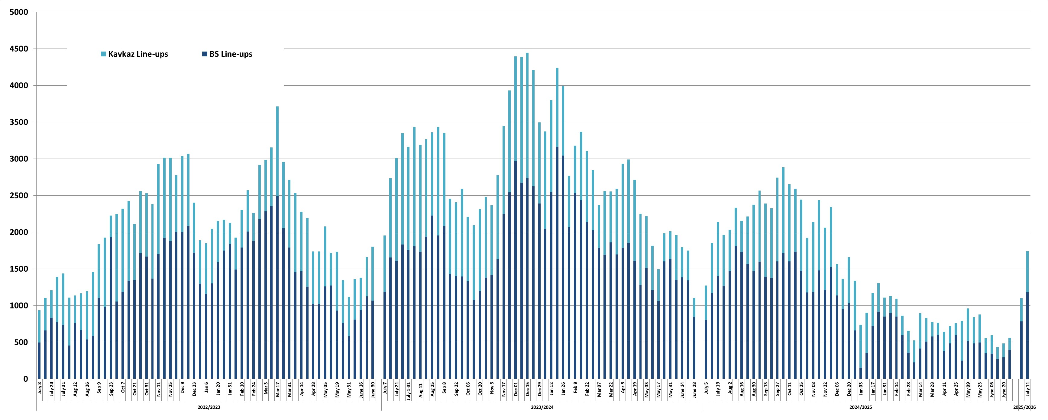

Rus grains export accrdng to pots and railways shipments dats, tmt
 | Wheat |  |  |  |  | Barley |  |  |  |  | Corn |  |  |  |  | All grains+pulses
 | 2023/24 | 2024/25 | 2025/26 |  |  | 2023/24 | 2024/25 | 2025/26 |  |  | 2023/24 | 2024/25 | 2025/26 |  |  | 2023/24 | 2024/25 | 2025/26
 |  |  | Ports | In-land | Total |  |  | Ports | In-land | Total |  |  | Ports | In-land | Total |  |  | Ports | In-land | Total
July* 1-11 | 4133 | 3647 | 257 | 0 | 257 | 1201 | 1001 | 37 | 0 | 37 | 547 | 325 | 145 | 0 | 145 | 6166 | 5152 | 445 | 0 | 445
August | 5367 | 5599 | 0 | 0 | 0 | 1177 | 603 | 0 | 0 | 0 | 276 | 274 | 0 | 0 | 0 | 7162 | 6648 | 0 | 0 | 0
September | 5345 | 5436 | 0 | 0 | 0 | 999 | 729 | 0 | 0 | 0 | 281 | 238 | 0 | 0 | 0 | 7508 | 6728 | 0 | 0 | 0
October | 5049 | 5814 | 0 | 0 | 0 | 545 | 562 | 0 | 0 | 0 | 595 | 344 | 0 | 0 | 0 | 6729 | 7260 | 0 | 0 | 0
November | 3397 | 4472 | 0 | 0 | 0 | 395 | 399 | 0 | 0 | 0 | 640 | 395 | 0 | 0 | 0 | 4792 | 5484 | 0 | 0 | 0
December | 3865 | 3846 | 0 | 0 | 0 | 363 | 180 | 0 | 0 | 0 | 591 | 378 | 0 | 0 | 0 | 5282 | 4749 | 0 | 0 | 0
January | 3938 | 2475 | 0 | 0 | 0 | 434 | 419 | 0 | 0 | 0 | 835 | 426 | 0 | 0 | 0 | 5590 | 3712 | 0 | 0 | 0
February | 4251 | 1928 | 0 | 0 | 0 | 456 | 263 | 0 | 0 | 0 | 843 | 228 | 0 | 0 | 0 | 5894 | 2644 | 0 | 0 | 0
March | 4646 | 1944 | 0 | 0 | 0 | 450 | 34 | 0 | 0 | 0 | 790 | 27 | 0 | 0 | 0 | 6304 | 2160 | 0 | 0 | 0
April | 4929 | 2263 | 0 | 0 | 0 | 977 | 34 | 0 | 0 | 0 | 651 | 53 | 0 | 0 | 0 | 6907 | 2567 | 0 | 0 | 0
May | 4660 | 2020 | 0 | 0 | 0 | 724 | 46 | 0 | 0 | 0 | 615 | 90 | 0 | 0 | 0 | 6343 | 2268 | 0 | 0 | 0
June | 4580 | 1289 | 0 | 0 | 0 | 591 | 16 | 0 | 0 | 0 | 514 | 48 | 0 | 0 | 0 | 5889 | 1446 | 0 | 0 | 0
Total | 54161 | 40734 | 257 | 0 | 257 | 8312 | 4286 | 37 | 0 | 37 | 7178 | 2825 | 145 | 0 | 145 | 74566 | 50817 | 445 | 0 | 445
Jul 1-11 | 1145 | 604 | 257 | 0 | 257 | 331 | 187 | 37 | 0 | 37 | 235 | 137 | 145 | 0 | 145 | 1781 | 1003 | 445 | 0 | 445
01.07-11.07 | 1145 | 604 | 257 | 0 | 257 | 331 | 187 | 37 | 0 | 37 | 235 | 137 | 145 | 0 | 145 | 1781 | 1003 | 445 | 0 | 445

Hot topic 2. Country export rating as of July 1-11, tmt (w/o railways)
All grains | 445 |  | Wheat | 257 |  | Barley | 37 |  | Corn | 145
TURKIYE | 140 |  | EGYPT | 87 |  | UAE | 21 |  | IRAN | 85
IRAN | 98 |  | TURKIYE | 75 |  | TURKIYE | 9 |  | TURKIYE | 57
EGYPT | 87 |  | UAE | 42 |  | IRAN | 8 |  | CYPRUS | 3
UAE | 63 |  | MOROCCO | 30
MOROCCO | 30 |  | LEBANON | 19
LEBANON | 19 |  | N/A | 5
N/A | 5
CYPRUS | 3

Hot topic 3. Ocean freight rates
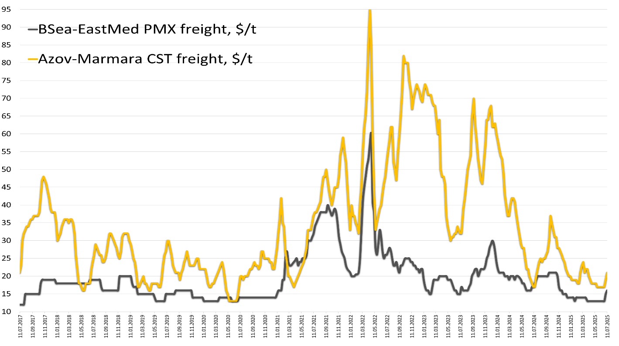

Hot topic 4. Amid geopolitical uncertainties, ruble is up to both dollar, and euro…
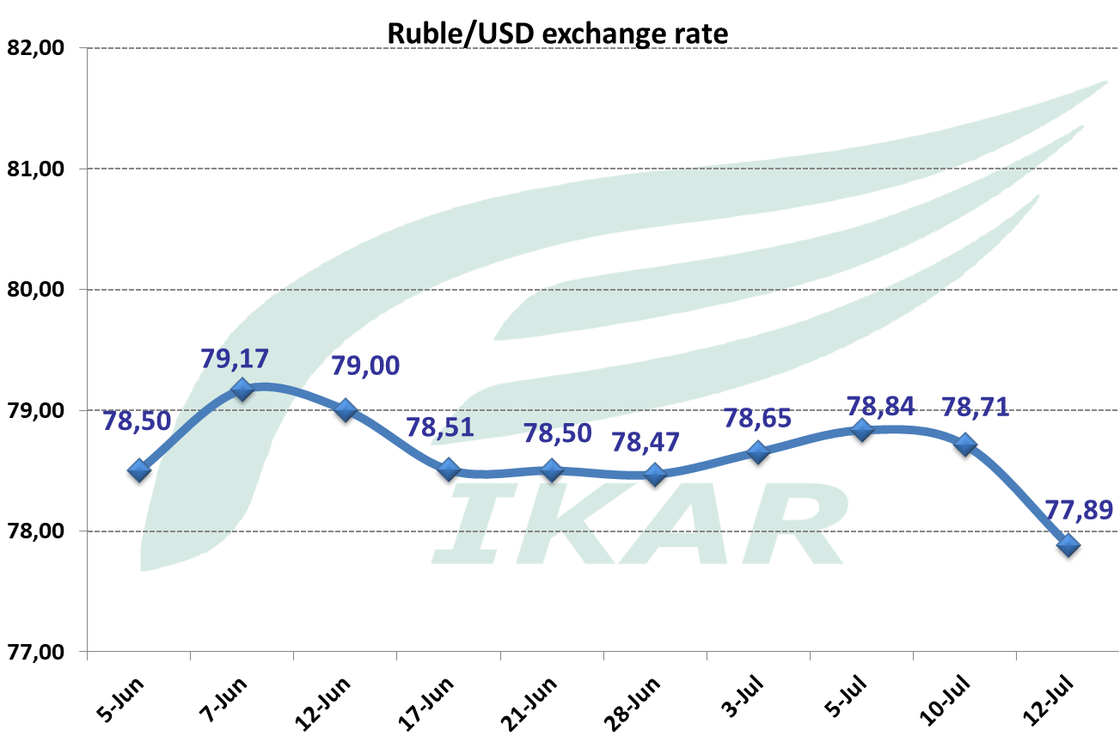
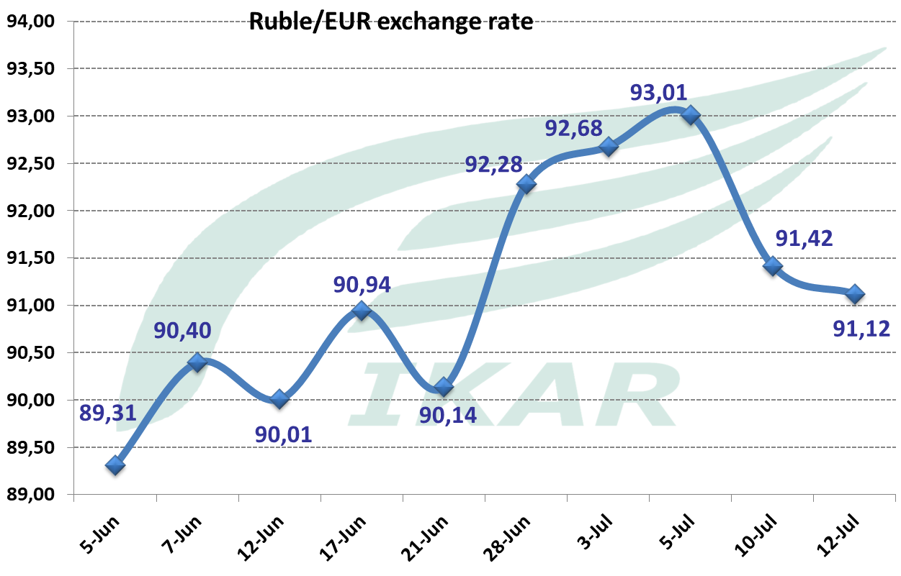

The dynamics of key grain currencies to dollar: in comparison with January 2024 and January 2025 ruble remains the strongest among the key grain currencies.

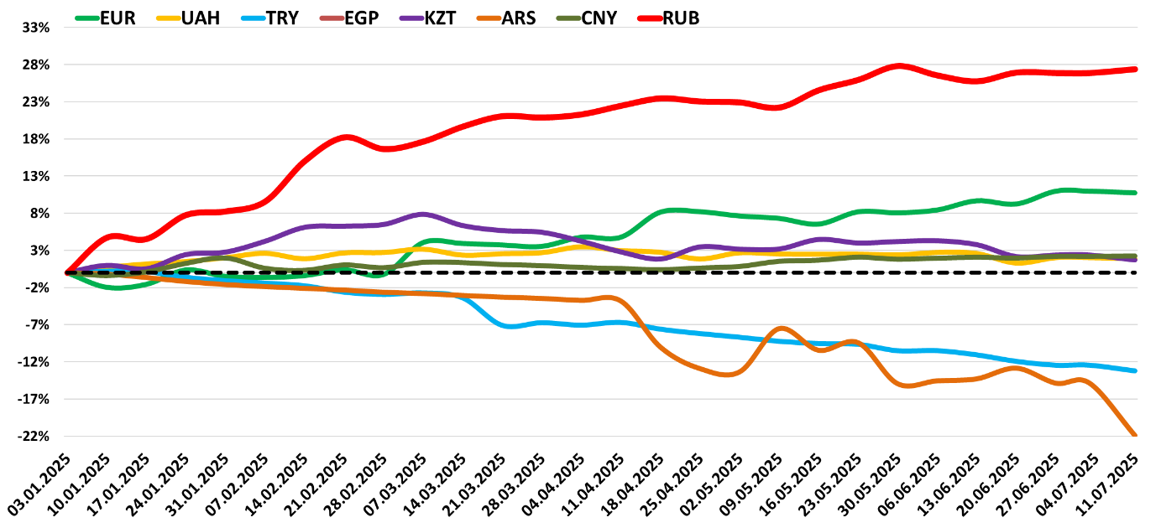

Hot topic 5. The dynamics of grain export duties. Liquidation of official export price control causes quite a sharp lowering of official “Moscow exchange” wheat export prices…

The weekly dynamics of Moscow “exchange”’ 3 grains price indexes for determining export duties, $/ton
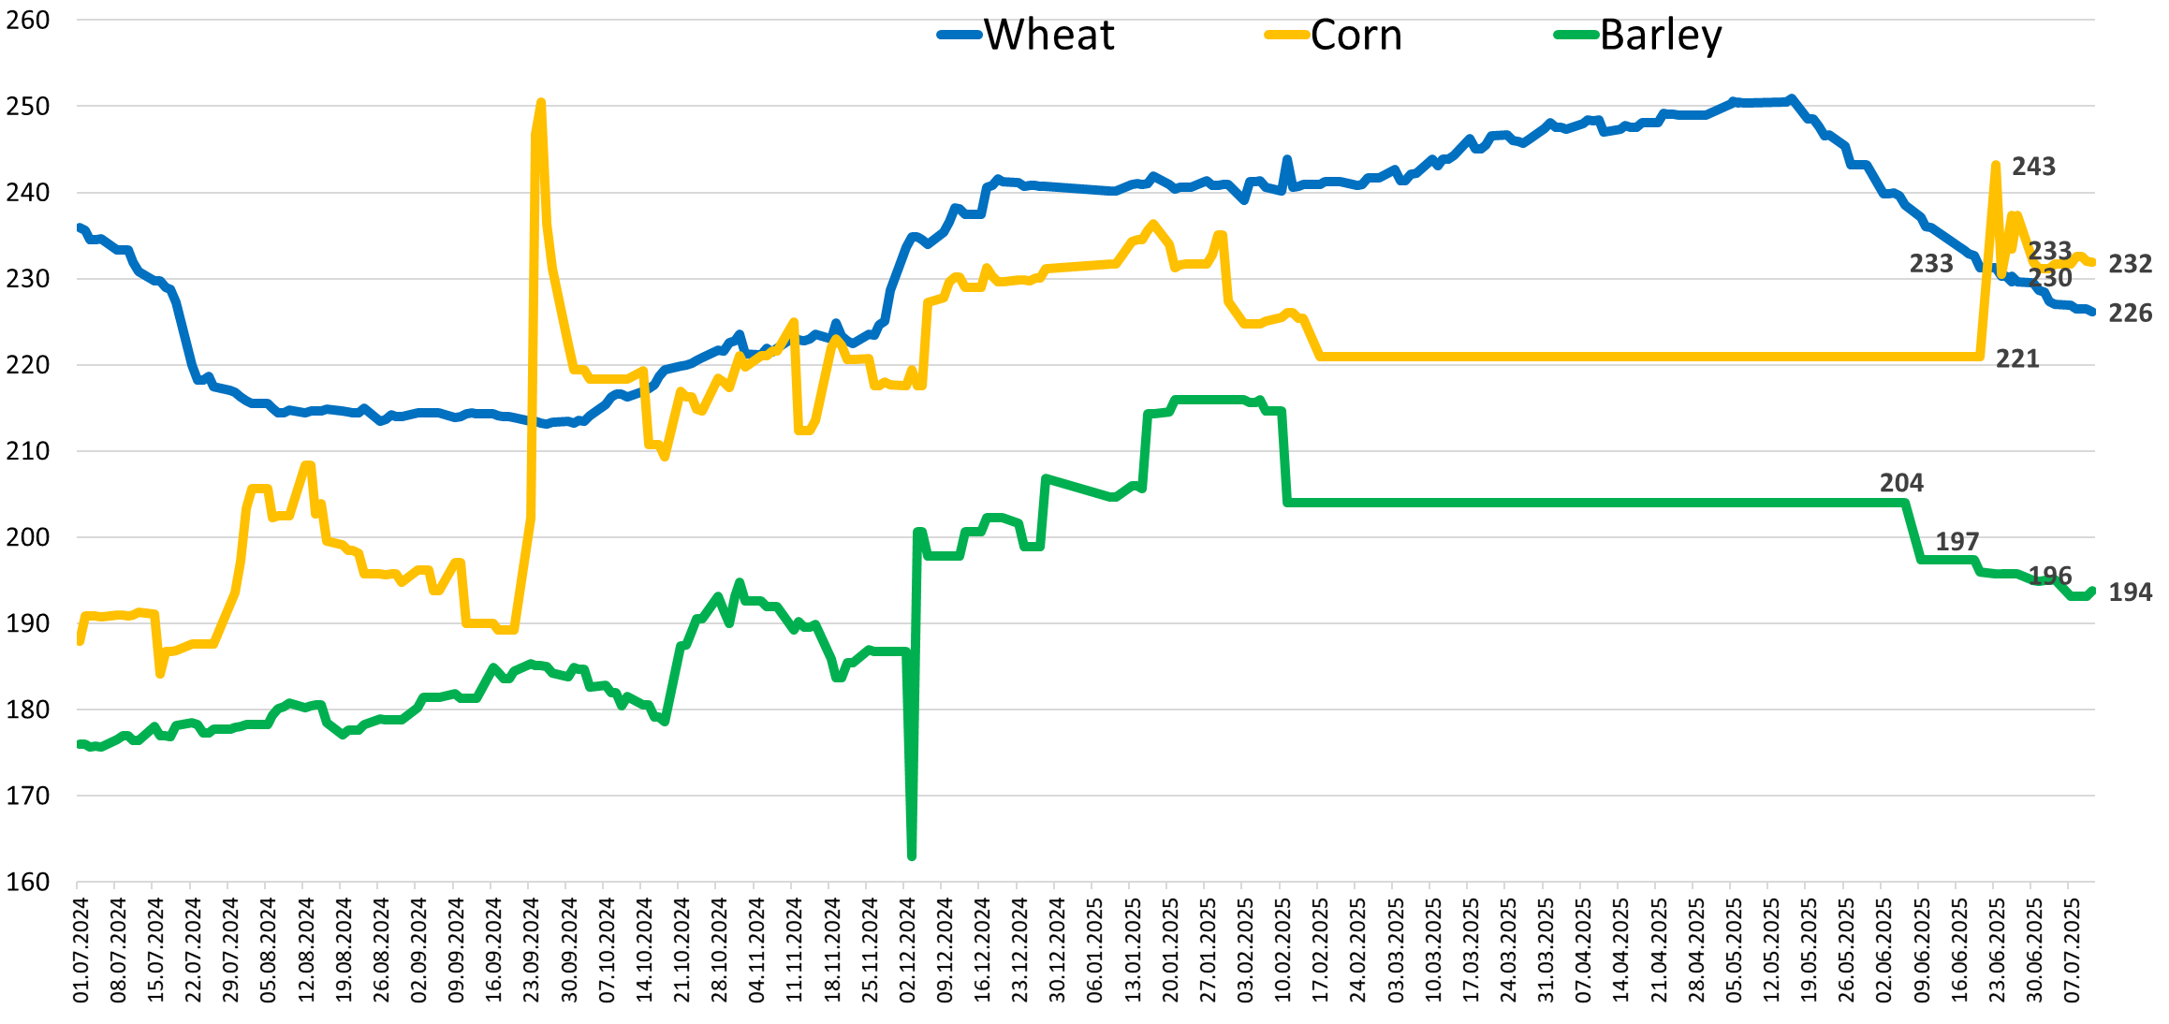

The dynamics of 3 weekly export duties, RUR/ton…
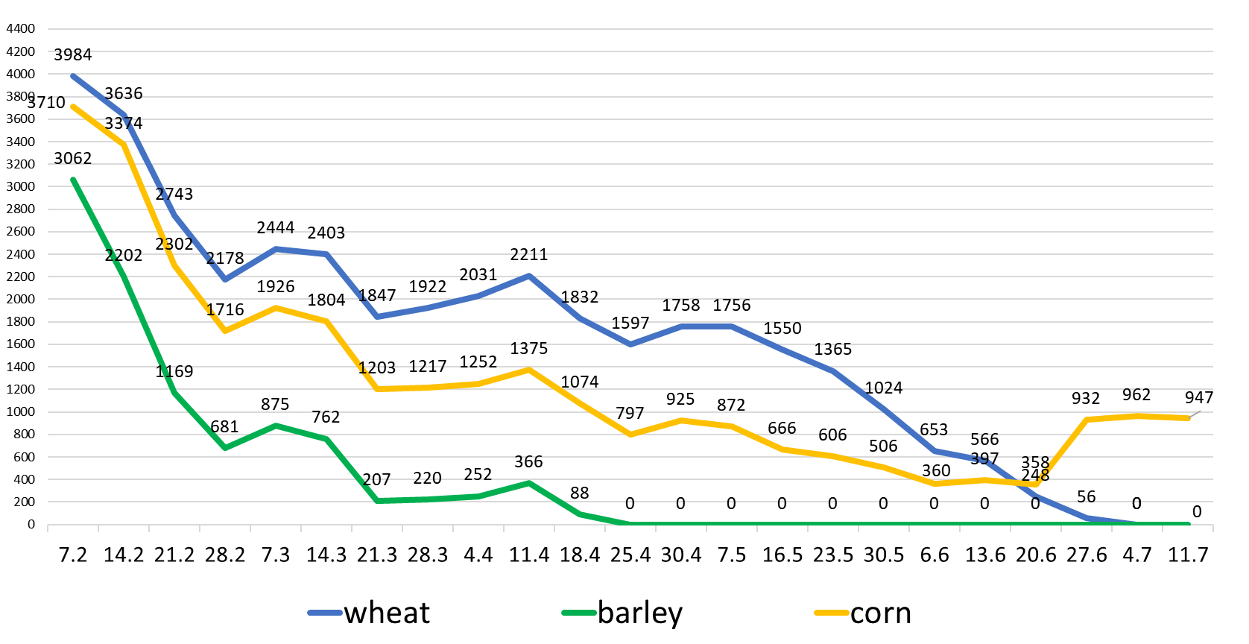

The dynamics of 3 weekly export duties, $/ton
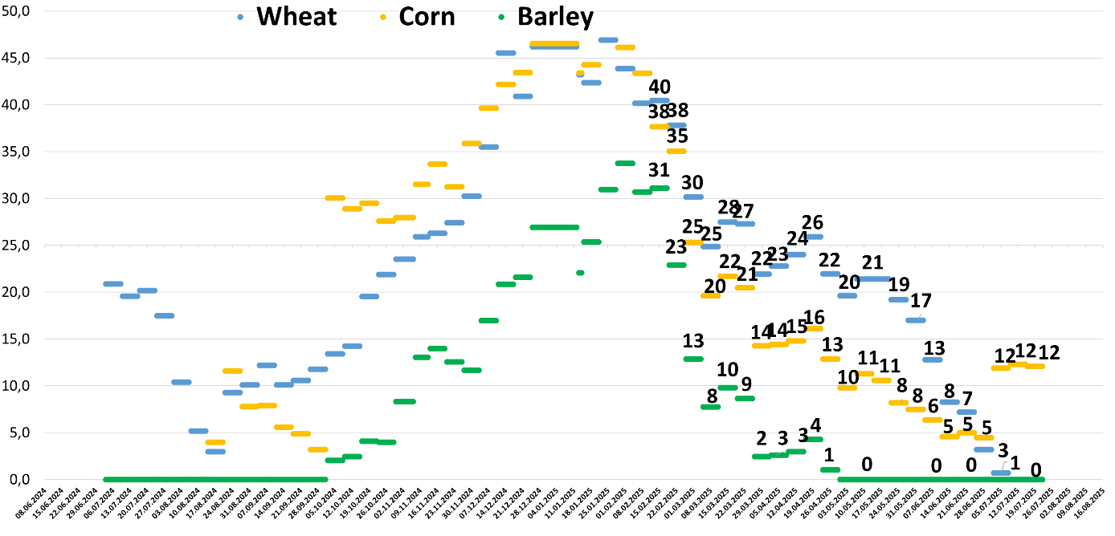

Hot topic 6. Two-week South Russian grain truck transportatation freight index, rur/ton/km

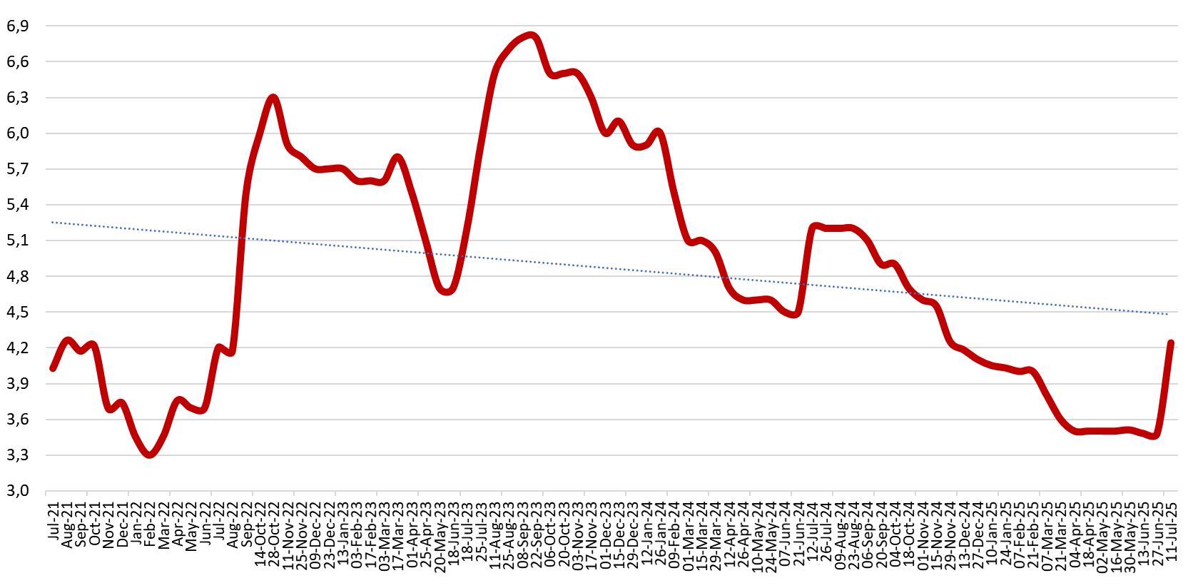
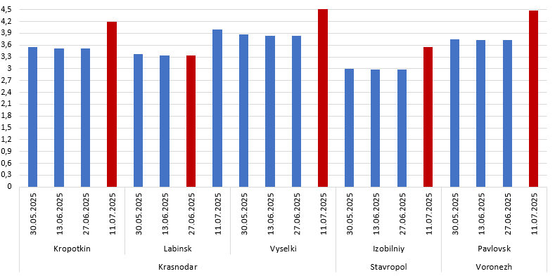

Date | Region | Indicative  Point | Destination  port | Distance, km | Price, RUB | Transportation cost,  RUB, 1mt/1km
30.05.2025 | Krasnodar | Vyselki | Novorossiysk | 250 | 970 | 3,9
13.06.2025 | Krasnodar | Vyselki | Novorossiysk | 250 | 960 | 3,8
27.06.2025 | Krasnodar | Vyselki | Novorossiysk | 250 | 960 | 3,8
11.07.2025 | Krasnodar | Vyselki | Novorossiysk | 250 | 1150 | 4,6
30.05.2025 | Krasnodar | Labinsk | Novorossiysk | 320 | 1080 | 3,4
13.06.2025 | Krasnodar | Labinsk | Novorossiysk | 320 | 1070 | 3,3
27.06.2025 | Krasnodar | Labinsk | Novorossiysk | 320 | 1070 | 3,3
11.07.2025 | Krasnodar | Labinsk | Novorossiysk | 320 | 1280 | 4,0
30.05.2025 | Krasnodar | Kropotkin | Novorossiysk | 310 | 1100 | 3,5
13.06.2025 | Krasnodar | Kropotkin | Novorossiysk | 310 | 1090 | 3,5
27.06.2025 | Krasnodar | Kropotkin | Novorossiysk | 310 | 1090 | 3,5
11.07.2025 | Krasnodar | Kropotkin | Novorossiysk | 310 | 1300 | 4,2
30.05.2025 | Stavropol | Izobilniy | Novorossiysk | 400 | 1200 | 3,0
13.06.2025 | Stavropol | Izobilniy | Novorossiysk | 400 | 1190 | 3,0
27.06.2025 | Stavropol | Izobilniy | Novorossiysk | 400 | 1190 | 3,0
11.07.2025 | Stavropol | Izobilniy | Novorossiysk | 400 | 1460 | 3,7
30.05.2025 | Voronezh | Pavlovsk | Azov | 440 | 1650 | 3,8
13.06.2025 | Voronezh | Pavlovsk | Azov | 440 | 1640 | 3,7
27.06.2025 | Voronezh | Pavlovsk | Azov | 440 | 1640 | 3,7
11.07.2025 | Voronezh | Pavlovsk | Azov | 440 | 1970 | 4,5

Hot topic 7. Russian Black and Azov Seas price indexes are up, amid rumors about real wheat production in Russia and Ukraine…

Amid deepening short-covering, during the week, the buyers at Black Sea terminals had to elevate new crop wheat purchase prices from RUR15400 to somewhat like RUR15800-15900 per ton of 12.5% wheat. For non-bound company, RUR15850 would provide about $227 as FOB cost equivalent (still w/o cost of finance), or, close to break-even, at best…

Azov Sea terminals new season 12.5% purchase prices are further up either, from RUR14300 previous week to RUR14850 (although with very high variation level) For non-bound company RUR14850 provides $199 as FOB cost equivalent (w/o cost of finance), or, taking into account elevation of coasters’ freight costs, about $222 as Port Kavkaz FOB equivalent (w/o cost of finance and potential demurrage)..

CPT export terminals Black Sea barley purchase price index is up from inceptional RUR13000-13200 to RUR13700-14000, and to RUR14500-14700 by the end of the week. For non-bound company it provides about $210-212 per ton as FOB cost equivalent (w/o cost of finance), or negative margin.

Across the continental European Russia prices continued to sag towards the new price realities.
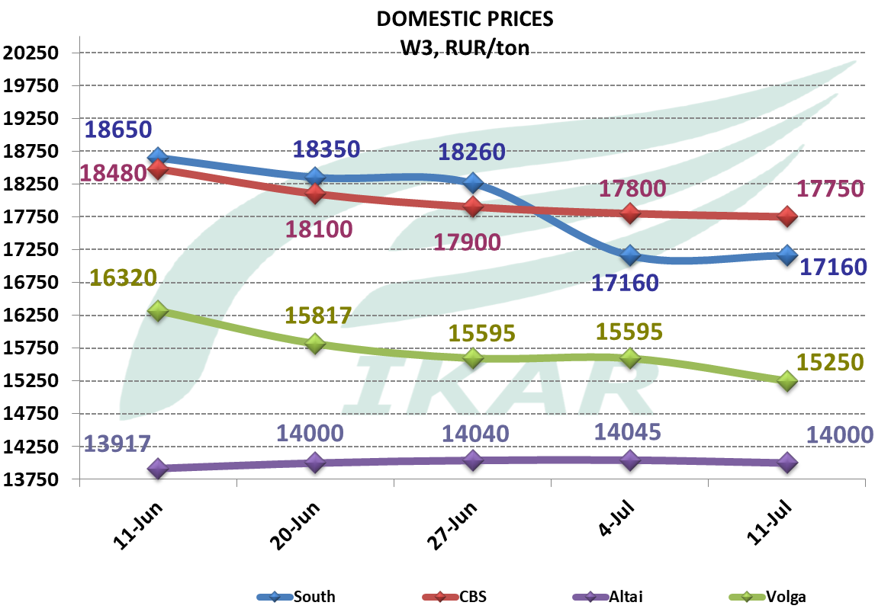
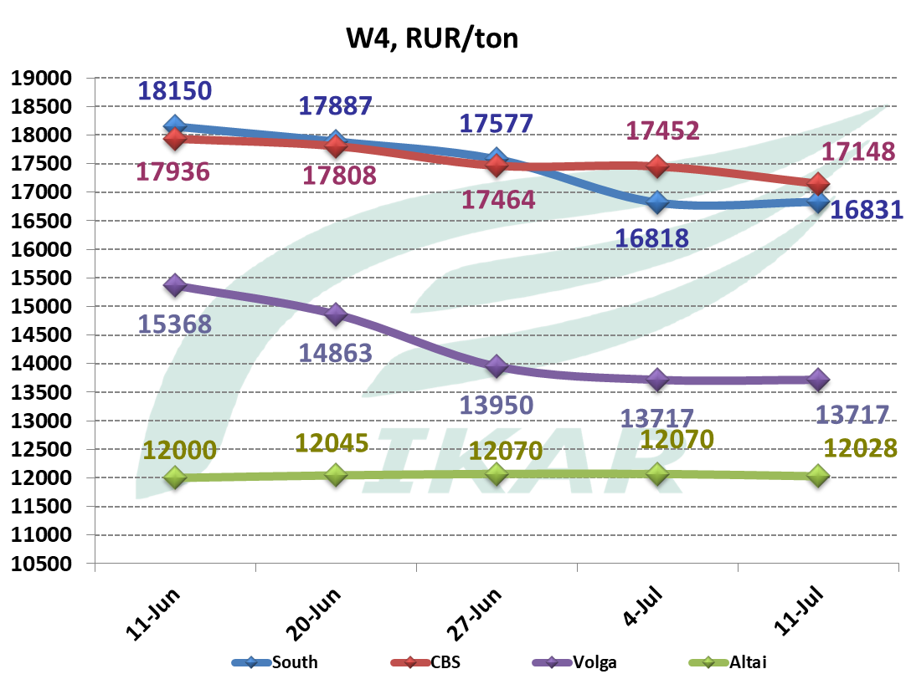
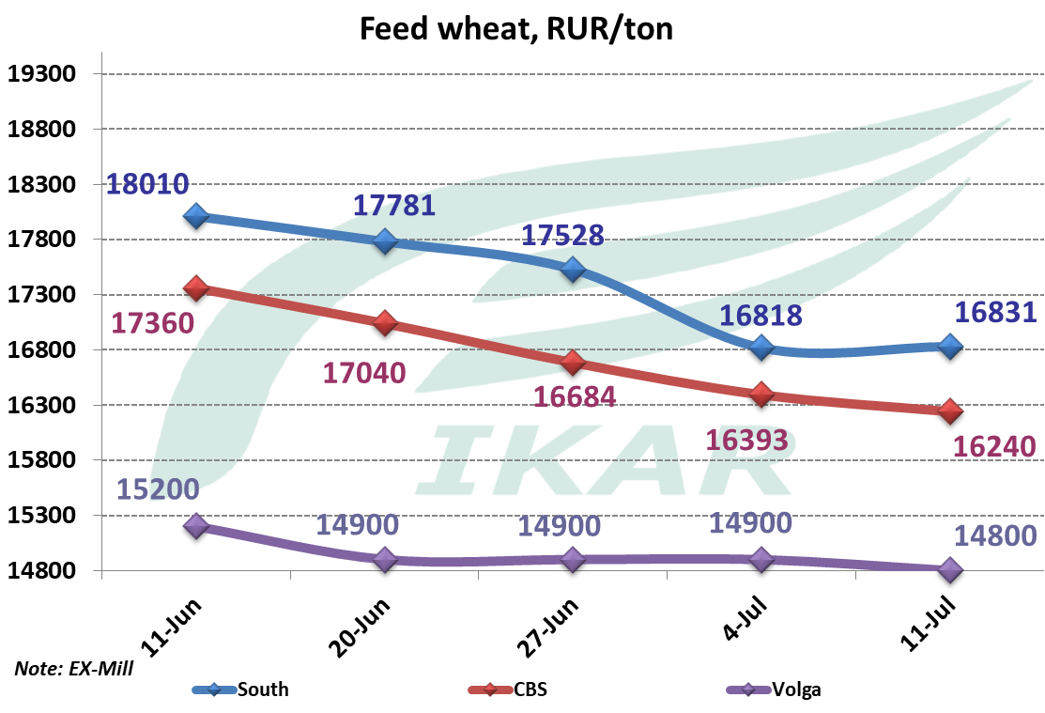
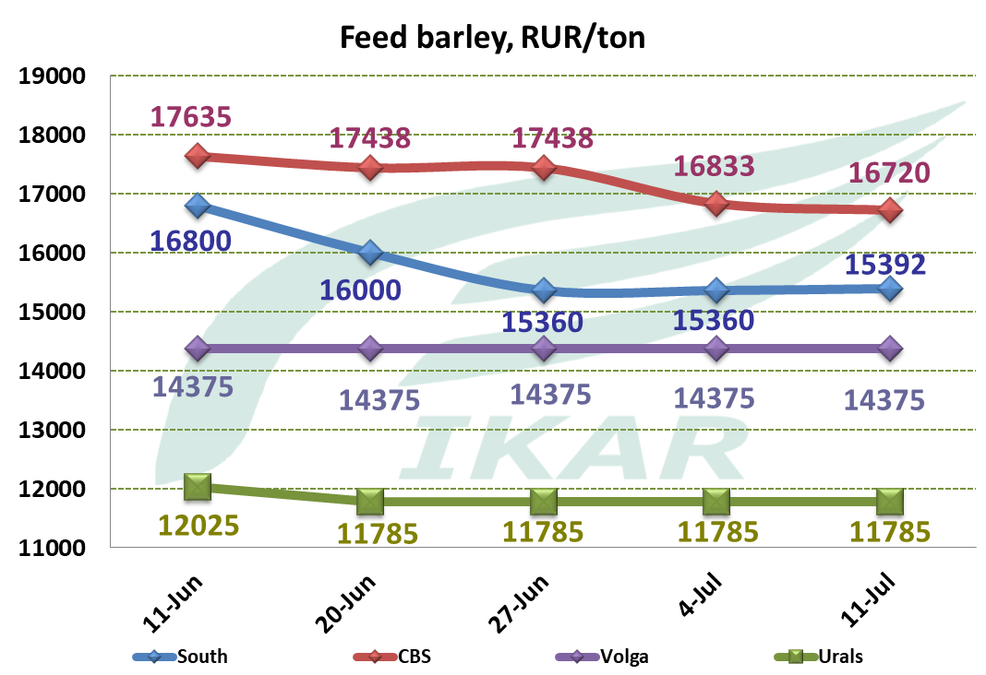

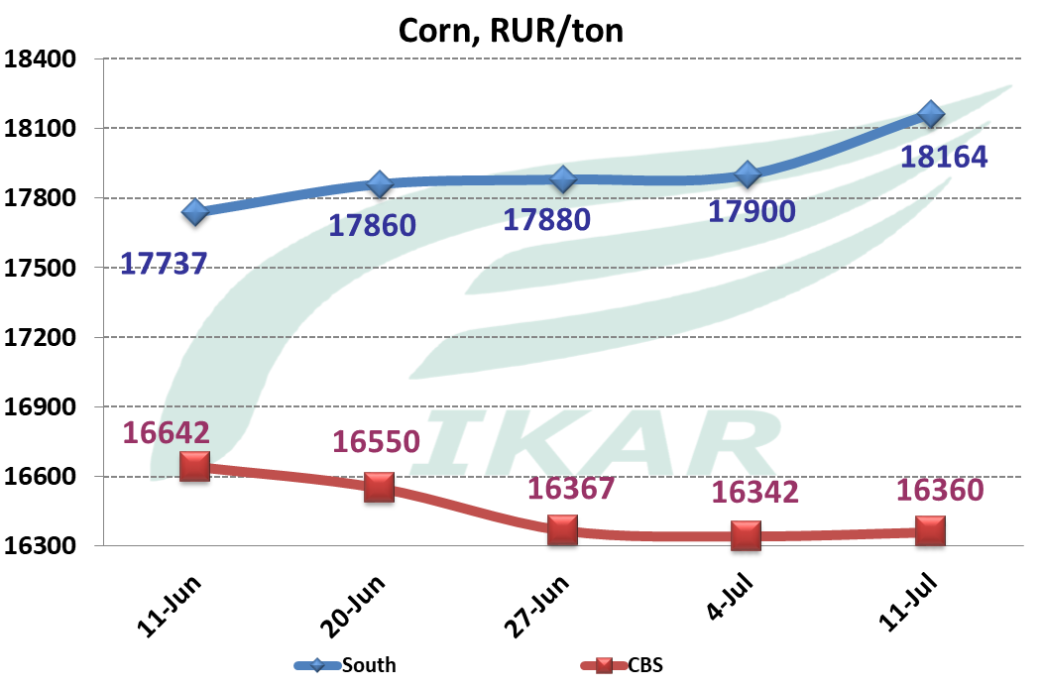
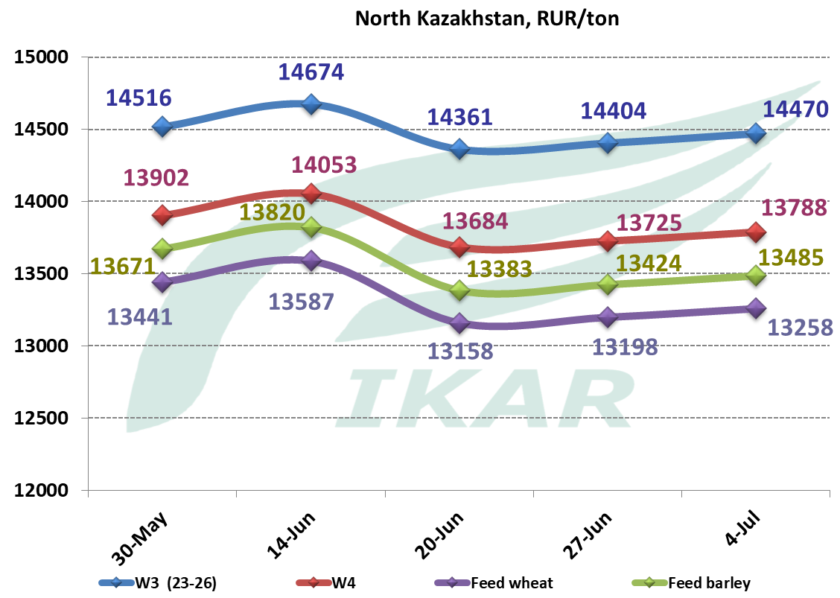

CPT Novo, Central, and Volga processors prices on 12.5% wheat, RUR/ton

Addendum

Harvest as of July 11, 2025

 | Grains and pulses
Region | Area | Area harvested,Th.ha. |  | collected, TMT bunker weight |  | Yield, metric centner/ha
Region | Area | 2025 | 2024 | 2025 | 2024 | 2025 | 2024
Russian Federation | n/a | 4 778,95 | 8 852,75 | 15424,2 | 32493,4 | 32,3 | 36,7
Rus Fed w/o new territories |  | 4409,9 | 8033,3 | 14762,9 | 30607,9 | 33,5 | 38,1
Central Federal District |  | 43 | 142 | 148,2 | 460,6 | 34,9 | 32,5
Belgorod |  |  | 56 | 25,7 | 216,0 |  | 38,8
Voronezh |  | 42 | 64 | 120,5 | 134,5 | 28,7 | 21,1
Tambov |  | 1 |  | 2,0 | 0,2 | 40,1 | 17,1
South Federal District |  | 2 923 | 5 408 | 8983,0 | 22172,9 | 30,7 | 41,0
Adyghe Republic |  | 27 | 98 | 147,0 | 490,5 | 55,3 | 49,9
Kalmuck Republic |  | 112 | 208 | 308,5 | 538,0 | 27,5 | 25,8
the Crimea |  | 339 | 498 | 684,5 | 1334,6 | 20,2 | 26,8
Krasnodar |  | 1 031 | 1 793 | 4628,0 | 11145,0 | 44,9 | 62,2
Astrakhan |  | 7 | 2 | 17,0 | 6,2 | 26,2 | 26,1
Volgograd |  | 265 | 597 | 681,0 | 1138,5 | 25,7 | 19,1
Rostov-on-Don |  | 1 143 | 2 211 | 2517,0 | 7520,0 | 22,0 | 34,0
North Caucasus District |  | 1 333 | 2 155 | 5383,7 | 7336,6 | 40,4 | 34,1
Republic of Dagestan |  | 49 | 40 | 129,5 | 96,0 | 26,4 | 24,3
Ingush Republic |  | 5 | 5 | 16,5 | 12,7 | 30,0 | 25,9
Kabardian-Balkar Republic |  | 27 | 26 | 110,5 | 106,4 | 41,2 | 40,5
Republic of Horth Ossetia-Alania |  | 4 | 15 | 18,2 | 45,5 | 40,5 | 30,3
Chechen Republic |  | 74 | 65 | 209,0 | 181,0 | 28,2 | 27,8
Stavropol |  | 1 173 | 1 997 | 4900,0 | 6865,7 | 41,8 | 34,4
Volga Federal District |  | 112 | 329 | 248,0 | 637,8 | 22,2 | 19,4
Orenburg |  | 13 |  | 32,5 |  | 25,0
Samara |  | 8 | 39 | 25,0 | 101,5 | 33,1 | 26,0
Saratov |  | 91 | 290 | 190,5 | 536,0 | 20,9 | 18,5
Total for new subjects |  | 369,0 | 819,5 | 661,3 | 1885,5 | 17,9 | 23,0
Donetsk |  | 36,0 | 115,5 | 68,3 | 273,0 | 19,0 | 23,6
Luhansk |  | 28,0 | 77,0 | 61,0 | 140,0 | 21,8 | 18,2
Zaporozhye |  | 72,0 | 291,0 | 119,0 | 752,4 | 16,5 | 25,9
Kherson |  | 233,0 | 336,0 | 413,0 | 720,1 | 17,7 | 21,4

 | WHEAT
Region | Area | Area harvested,Th.ha. |  | collected, TMT bunker weight |  | Yield, metric centner/ha
Region | Area | 2025 | 2024 | 2025 | 2024 | 2025 | 2024
Russian Federation | n/a | 3352,7 | 6731,6 | 11283,8 | 26199,0 | 33,7 | 38,9
Rus Fed w/o new territories |  | 3219,9 | 6195,2 | 10998,8 | 24834,5 | 34,2 | 40,1
Central Federal District |  | 38,2 | 125,1 | 112,7 | 412,2 | 29,5 | 32,9
Belgorod |  | 4,0 | 49,0 | 16,7 | 201,5 | 41,8 | 41,1
Voronezh |  | 34,0 | 57,5 | 95,3 | 119,5 | 28,0 | 20,8
Kursk |  | 0,0 | 13,8 | 0,0 | 70,4 |  | 51,0
Lipetsk |  | 0,0 | 4,8 | 0,0 | 20,8 |  | 43,3
Tambov |  | 0,2 | 0,0 | 0,7 | 0,0 | 45,3
South Federal District |  | 2196,8 | 4571,7 | 6994,2 | 19454,7 | 31,8 | 42,6
Adyghe Republic |  | 18,5 | 90,0 | 105,5 | 448,0 | 57,0 | 49,8
Kalmuck Republic |  | 94,2 | 186,8 | 270,8 | 498,5 | 28,7 | 26,7
the Crimea |  | 155,0 | 275,1 | 345,0 | 810,2 | 22,3 | 29,5
Krasnodar |  | 733,0 | 1497,0 | 3375,0 | 9614,0 | 46,0 | 64,2
Astrakhan |  | 2,1 | 2,3 | 5,4 | 5,9 | 26,0 | 26,0
Volgograd |  | 260,0 | 592,5 | 672,0 | 1133,0 | 25,8 | 19,1
Rostov-on-Don |  | 934,0 | 1928,0 | 2220,5 | 6945,0 | 23,8 | 36,0
North Caucasus District |  | 876,0 | 1172,4 | 3648,5 | 4334,3 | 41,6 | 37,0
Republic of Dagestan |  | 21,2 | 16,1 | 56,6 | 41,4 | 26,7 | 25,7
Ingush Republic |  | 1,0 | 1,0 | 3,1 | 3,2 | 31,2 | 31,3
Kabardian-Balkar Republic |  | 15,2 | 13,5 | 64,4 | 74,2 | 42,2 | 55,0
Karachaevo-Cherkessya Republic |  | 0,0 | 5,0 | 0,0 | 23,9 |  | 47,9
Republic of Horth Ossetia-Alania |  | 0,7 | 12,1 | 2,2 | 37,0 | 29,9 | 30,5
Chechen Republic |  | 34,9 | 36,7 | 99,7 | 107,9 | 28,6 | 29,4
Stavropol |  | 803,0 | 1088,0 | 3422,5 | 4046,8 | 42,6 | 37,2
Volga Federal District |  | 108,9 | 326,0 | 243,4 | 633,3 | 22,3 | 19,4
Chuvash Republic |  | 0,0 | 0,1 | 0,0 | 0,3 |  | 27,0
Orenburg |  | 12,0 | 0,0 | 31,8 | 0,0 | 26,5
Samara |  | 7,4 | 38,9 | 24,3 | 101,5 | 32,7 | 26,1
Saratov |  | 89,5 | 287,0 | 187,3 | 531,5 | 20,9 | 18,5
Total for new subjects |  | 132,8 | 536,4 | 285,1 | 1364,5 | 21,5 | 25,4
Donetsk |  | 25,0 | 88,8 | 49,9 | 227,9 | 20,0 | 25,7
Luhansk |  | 23,5 | 67,6 | 52,6 | 127,5 | 22,4 | 18,9
Zaporozhye |  | 25,7 | 196,8 | 53,0 | 563,6 | 20,6 | 28,6
Kherson |  | 58,6 | 183,2 | 129,6 | 445,5 | 22,1 | 24,3

 | BARLEY
Region | Area | Area harvested,Th.ha. |  | collected, TMT bunker weight |  | Yield, metric centner/ha
Region | Area | 2025 | 2024 | 2025 | 2024 | 2025 | 2024
Russian Federation | n/a | 873,6 | 965,7 | 2941,7 | 3473,0 | 33,7 | 36,0
Rus Fed w/o new territories |  | 700,7 | 747,0 | 2622,8 | 3025,9 | 37,4 | 40,5
Central Federal District |  | 6,9 | 7,0 | 28,4 | 25,5 | 41,2 | 36,5
Belgorod |  |  | 0,8 | 8,3 | 2,8 |  | 36,8
Voronezh |  | 6,9 | 3,3 | 20,1 | 7,4 | 29,1 | 22,2
Kursk |  | 0,0 | 2,9 | 0,0 | 15,4 |  | 52,8
South Federal District |  | 437,0 | 500,3 | 1499,3 | 2096,5 | 34,3 | 41,9
Adyghe Republic |  | 8,2 | 8,3 | 41,2 | 40,5 | 50,3 | 48,8
Kalmuck Republic |  | 6,5 | 9,7 | 18,2 | 22,4 | 27,9 | 23,2
the Crimea |  | 162,5 | 183,4 | 323,6 | 476,5 | 19,9 | 26,0
Krasnodar |  | 167,0 | 173,4 | 949,1 | 1222,2 | 56,8 | 70,5
Astrakhan |  | 3,8 | 0,1 | 10,8 | 0,3 | 28,1 | 28,1
Volgograd |  | 5,2 | 2,8 | 9,0 | 4,8 | 17,3 | 16,8
Rostov-on-Don |  | 83,8 | 122,6 | 147,3 | 329,7 | 17,6 | 26,9
North Caucasus District |  | 256,5 | 239,7 | 1094,8 | 903,9 | 42,7 | 37,7
Republic of Dagestan |  | 27,5 | 23,3 | 72,9 | 54,6 | 26,5 | 23,4
Ingush Republic |  | 4,5 | 3,9 | 13,1 | 9,5 | 29,1 | 24,3
Kabardian-Balkar Republic |  | 11,6 | 8,5 | 45,7 | 32,3 | 39,5 | 38,0
Karachaevo-Cherkessya Republic |  | 0,0 | 1,3 | 0,0 | 5,5 |  | 42,6
Republic of Horth Ossetia-Alania |  | 3,8 | 2,3 | 15,9 | 7,4 | 42,2 | 32,1
Chechen Republic |  | 32,1 | 24,9 | 89,7 | 66,9 | 27,9 | 26,8
Stavropol |  | 177,0 | 175,4 | 857,5 | 727,7 | 48,4 | 41,5
Volga Federal District |  | 0,3 | 0,0 | 0,4 | 0,0 | 13,1
Saratov |  | 0,3 |  | 0,4 | 0,0 | 13,1
Total for new subjects |  | 172,8 | 218,7 | 318,9 | 447,1 | 18,4 | 20,4
Donetsk |  | 6,2 | 18,2 | 12,0 | 36,0 | 19,5 | 19,7
Luhansk |  | 3,8 | 7,7 | 7,6 | 10,3 | 19,9 | 13,3
Zaporozhye |  | 22,7 | 59,7 | 43,2 | 150,2 | 19,0 | 25,2
Kherson |  | 140,1 | 133,1 | 256,1 | 250,5 | 18,3 | 18,8

 | RAPE
Region | Area (расчет) | Area harvested,Th.ha. |  | collected, TMT bunker weight |  | Yield, metric centner/ha
Region | Area (расчет) | 2025 | 2024 | 2025 | 2024 | 2025 | 2024
Russian Federation | n/a | 123,9 | 218,5 | 223,0 | 415,0 | 18,0 | 19,0
Rus Fed w/o new territories |  | 88,5 | 147,5 | 169,5 | 344,4 | 19,2 | 23,4
South Federal District |  | 40,1 | 74,4 | 93,6 | 200,3 | 23,3 | 26,9
Adyghe Republic |  | 4,8 | 8,9 | 12,8 | 17,8 | 26,6 | 20,0
the Crimea |  | 9,0 | 2,2 | 12,9 | 3,4 | 14,4 | 15,2
Krasnodar |  | 26,3 | 63,3 | 67,8 | 179,1 | 25,8 | 28,3
North Caucasus District |  | 48,4 | 71,1 | 75,9 | 138,5 | 15,7 | 19,5
Ingush Republic |  | 0,7 | 0,0 | 0,7 | 0,0 | 9,3
Kabardian-Balkar Republic |  | 2,7 | 6,0 | 5,9 | 13,2 | 22,1 | 22,0
Chechen Republic |  | 18,9 | 16,9 | 27,2 | 22,8 | 14,4 | 13,4
Stavropol |  | 26,0 | 37,7 | 42,1 | 80,7 | 16,2 | 21,4
Total for new subjects |  | 35,5 | 71,0 | 53,5 | 70,6 | 15,1 | 9,9
Zaporozhye |  | 1,4 | 18,9 | 1,1 | 21,9 | 7,4 | 11,6
Kherson |  | 34,0 | 51,7 | 52,5 | 48,4 | 15,4 | 9,4

